Task 8 – Robustness and Portfolio Stability
Using the same in-sample / out-of-sample split as Task 7 (1980–2002 / 2003–2025), we assess whether simple robustness adjustments improve portfolio stability. Table 8.1 reports in-sample (IS) and out-of-sample (OOS) Sharpe ratios for four approaches: (A) unconstrained optimisation, (B) 10% position cap, (C) Michaud-style resampling (50 bootstrap draws), and (D) an expanded 35-asset universe (30 industries plus the Fama–French five factors). The equal-weight (1/N) portfolio is included as a benchmark. Portfolios are optimised in-sample and held fixed out-of-sample.

Table 8.1 – In-Sample vs Out-of-Sample Performance (Monthly Excess Returns)
Strategy | SR (IS) | SR (OOS) | ΔSR | OOS σ | OOS μ
Unconstrained – Tangency | 0.337 | 0.082 | −0.255 | 6.29% | 0.65%
Unconstrained – GMV | 0.175 | 0.186 | +0.011 | 3.62% | 0.81%
10% Cap – Tangency | 0.204 | 0.209 | +0.005 | 3.60% | 0.89%
10% Cap – GMV | 0.180 | 0.191 | +0.011 | 3.92% | 0.89%
Resampled – Tangency | 0.211 | 0.214 | +0.003 | 3.60% | 0.91%
Resampled – GMV | 0.161 | 0.203 | +0.042 | 3.53% | 0.85%
Equal weight (1/N) | 0.135 | 0.185 | +0.049 | 4.80% | 1.02%
35-Asset – Tangency | 0.713 | 0.193 | −0.520 | 1.00% | 0.19%
35-Asset – GMV | 0.442 | 0.158 | −0.284 | 1.29% | 0.20%

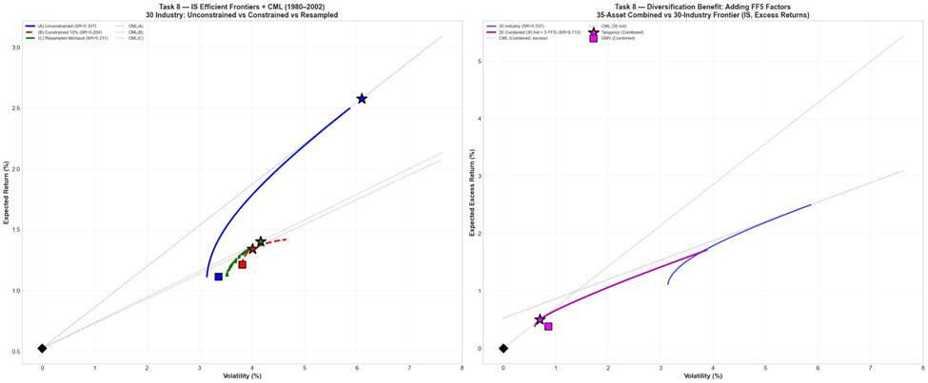Figure 8.1 – In-Sample Efficient Frontiers and Capital Market Lines (1980–2002)

Tangency Portfolios Results
The unconstrained tangency portfolio achieves the highest in-sample Sharpe ratio (0.337), but its OOS Sharpe falls sharply to 0.082 (ΔSR = −0.255), with volatility rising to 6.29% per month. This confirms the instability observed in Task 7.
Imposing a 10% weight cap reduces the IS Sharpe to 0.204 but eliminates OOS deterioration (SR(OOS) = 0.209, ΔSR = +0.005), cutting volatility to 3.60%. The resampled tangency produces nearly identical stability (IS SR = 0.211, OOS SR = 0.214). By averaging weights across bootstrap samples, it avoids overfitting to any single realisation of the data.
Expanding the universe to 35 assets dramatically increases the IS Sharpe to 0.713, but the gain reverses OOS (SR = 0.193, ΔSR = −0.520). With N = 35 and only T = 276 months, additional parameters amplify estimation error, resulting in severe OOS performance decay.

GMV and Equal-Weight Results
Across all 30-industry specifications, GMV portfolios exhibit minimal IS–OOS Sharpe changes (ΔSR between +0.011 and +0.042), reflecting their independence from noisy mean return estimates. The resampled GMV achieves the strongest OOS Sharpe (0.203).
The 1/N portfolio delivers an OOS Sharpe of 0.185, substantially outperforming the unconstrained tangency (0.082). The constrained and resampled tangency portfolios modestly exceed 1/N, indicating that optimisation retains value when properly regularised.

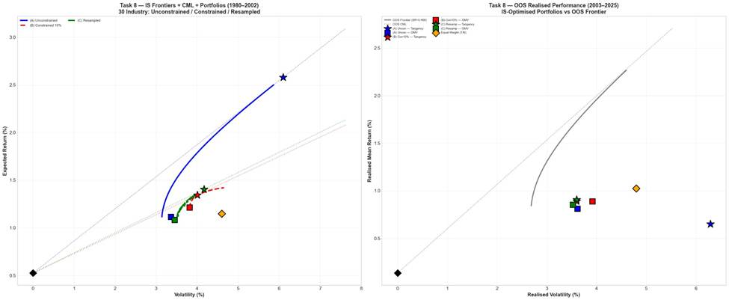Figure 8.2 – IS Portfolios vs OOS Realised Performance (2003–2025)

Statistical Evidence
Sharpe ratio equality is tested using Jobson–Korkie (1981) and Ledoit–Wolf (2008) procedures. The LW test is preferred, as it does not require i.i.d. or normality assumptions.

Table 8.2 – Sharpe Ratio Equality Tests
Comparison | JK p-value | LW p-value | Finding
Unconstrained Tangency: IS → OOS | p < 0.001 | p = 0.001 | Significant IS–OOS deterioration
10% Cap Tangency: IS → OOS | p < 0.001 | p = 0.960 | No detectable deterioration
Resampled Tangency: IS → OOS | p < 0.001 | p = 0.986 | No detectable deterioration
10% Cap vs Uncon. Tangency (OOS) | p < 0.001 | p = 0.035 | Constrained significantly outperforms
Resampled vs Uncon. Tangency (OOS) | p < 0.001 | p = 0.025 | Resampled significantly outperforms
1/N vs Uncon. Tangency (OOS) | p < 0.001 | p = 0.121 | Outperforms; not significant at 5%

The LW test confirms significant IS–OOS deterioration for the unconstrained tangency (p = 0.001). Neither the capped nor resampled portfolios exhibit significant deterioration (p > 0.96). Both regularised tangency portfolios significantly outperform the unconstrained benchmark OOS (p = 0.035 and 0.025 respectively), indicating that the improvement reflects genuine robustness rather than sampling variation.

Conclusion
The unconstrained tangency portfolio is highly efficient in-sample but unreliable out-of-sample. Simple regularisation, either through position limits or resampling, substantially stabilises performance at modest in-sample cost. GMV portfolios remain comparatively stable, whereas expanding the asset set without more data deteriorates out-of-sample performance. Optimisation only adds value when estimation risk is controlled.

Task 9 – Mutual Fund Performance Assessment
We assess the performance of three mutual funds against the market portfolio, the FF5 practical proxies, and the tangency portfolios constructed in Tasks 2 and 6. The three funds are described in Table 9.1. VFINX is included as a passive benchmark; FMAGX and AGTHX are actively managed large-cap growth funds. All regressions use monthly excess returns with the longest available overlapping sample for each benchmark.

Table 9.1 – Fund Characteristics
Ticker | Fund | Style | Inception | Exp. Ratio
VFINX | Vanguard 500 Index | Passive (S&P 500) | 1976 | 0.14%
FMAGX | Fidelity Magellan | Active Large-Cap Growth | 1963 | 0.67%
AGTHX | Growth Fund of America | Active Large-Cap Growth | 1973 | 0.62%

Table 9.2 – Alpha Estimates and Sharpe Ratios by Benchmark (Monthly Excess Returns, Feb 1980–Dec 2025)
Fund | CAPM α (%) | t | FF5-Proxy α (%) | t | Tangency α (%) | t | OOS SR
VFINX | −0.025 | −0.73 | −0.006 | −0.79 | −0.125 | −0.79 | 0.153
FMAGX | +0.497 | +3.80 | +0.552 | +2.60 | +0.444 | +1.98 | 0.224
AGTHX | +0.311 | +2.77 | +0.743 | +3.24 | +0.329 | +1.58 | 0.199

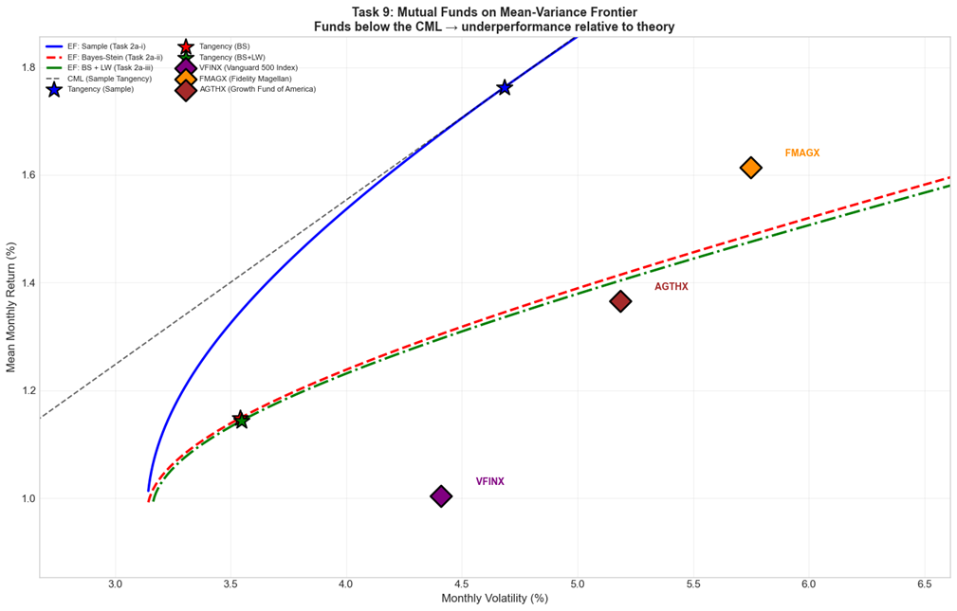Figure 9.1 – Mutual Funds on the Mean–Variance Frontier

VFINX – Vanguard 500 Index (Passive)
As expected for a passive S&P 500 tracker, VFINX produces near-zero alpha across all benchmarks: α = −0.025%/month under CAPM (t = −0.73, insignificant) and effectively zero under the FF5 proxies (α = −0.006%, t = −0.79, R² = 0.9995). The fund's full-sample Sharpe ratio of 0.153 lies below the in-sample tangency portfolio’s Sharpe ratio. The negative tangency alpha (−0.125%) reflects that the in-sample tangency portfolio represents the maximum Sharpe portfolio within the sample. This is a particularly demanding benchmark.

FMAGX – Fidelity Magellan (Active)
FMAGX generates a significant positive CAPM alpha of +0.497%/month (t = 3.80), suggesting genuine outperformance over the market. Under the FF5 proxies, alpha remains positive at +0.552%/month (t = 2.60) and becomes only marginally significant against the tangency portfolio (α = +0.444%, t = 1.98). The large negative loading on IWD (β = −0.46) and positive loading on SPY (β = 1.47) indicate a strong growth tilt. Much of the apparent CAPM alpha reflects systematic factor exposure rather than stock selection skill. The fund's Sharpe ratio of 0.224 remains below the in-sample tangency portfolio.

AGTHX – Growth Fund of America (Active)
AGTHX also shows significant CAPM alpha (+0.311%/month, t = 2.77), which grows to +0.743%/month under FF5 proxies (t = 3.24) — the largest alpha in the sample. This increase reflects that the FF5 proxy model partially fails to capture AGTHX's style exposures, as the R² actually falls from 0.784 to 0.726, suggesting the fund holds assets not well spanned by these proxies. As with FMAGX, the tangency alpha is positive but insignificant (t = 1.58). The fund's Sharpe ratio of 0.199 lies below the in-sample tangency portfolio.

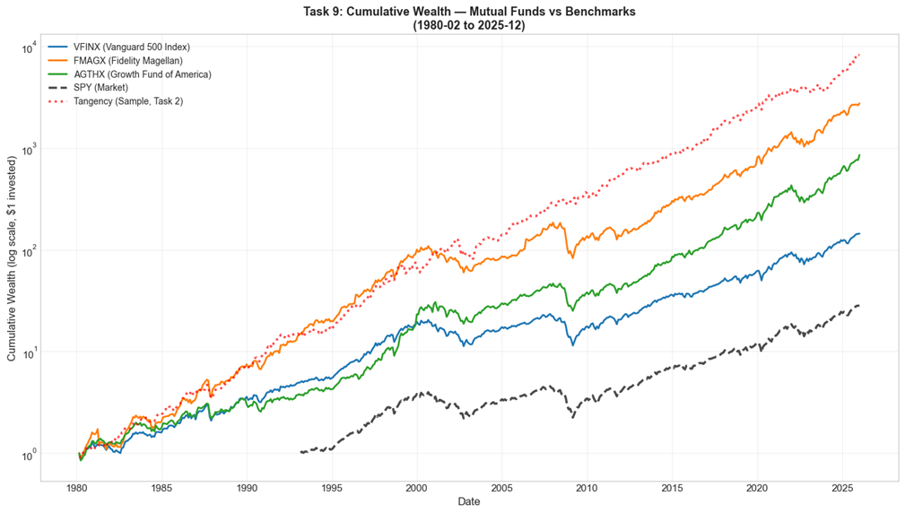Figure 9.2 – Cumulative Wealth: Funds vs Benchmarks

Conclusion
All three funds underperform the in-sample tangency portfolio, which by construction delivers the highest Sharpe ratio in the sample. The passive fund (VFINX) correctly shows α ≈ 0 across all benchmarks. The active funds show significant CAPM alphas, but these diminish or become insignificant when controlling for factor exposures, indicating that apparent skill partly reflects systematic tilts toward growth and large-cap equities. The tangency portfolio is uniformly the most demanding benchmark.

Bibliography
DeMiguel, V., Garlappi, L. and Uppal, R. (2009) ‘Optimal versus Naive Diversification: How Inefficient Is the 1/N Portfolio Strategy?’, Review of Financial Studies, 22(5), pp. 1915–1953.

Jagannathan, R. and Ma, T. (2003) ‘Risk Reduction in Large Portfolios: Why Imposing the Wrong Constraints Helps’, Journal of Finance, 58(4), pp. 1651–1683.

Jensen, M.C. (1968) ‘The Performance of Mutual Funds in the Period 1945–1964’, Journal of Finance, 23(2), pp. 389–416.

Jobson, J.D. and Korkie, B.M. (1981) ‘Performance Hypothesis Testing with the Sharpe and Treynor Measures’, Journal of Finance, 36(4), pp. 889–908.

Ledoit, O. and Wolf, M. (2008) ‘Robust Performance Hypothesis Testing with the Sharpe Ratio’, Journal of Empirical Finance, 15(5), pp. 850–859.

Michaud, R.O. (1989) ‘The Markowitz Optimization Enigma: Is “Optimized” Optimal?’, Financial Analysts Journal, 45(1), pp. 31–42.

